**Day 5 Assignment**

Difference between Truncate and Delete statement in MySql.

**Truncate statement:**

Truncate table command will delete the whole records in the table. It doesn’t need a where condition. It will leave the table as it is and addition of new record is possible on a table after truncation.

Syntax : TRUNCATE TABLE <table-name>

Eg: TRUNCATE TABLE Persons.

Existing table

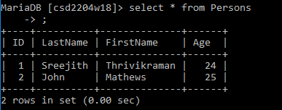

Truncated Table:

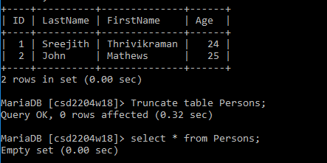

**DELETE statement:**

Delete statement will delete the specific row from the table based on a specific condition. It requires a ‘where’ condition.

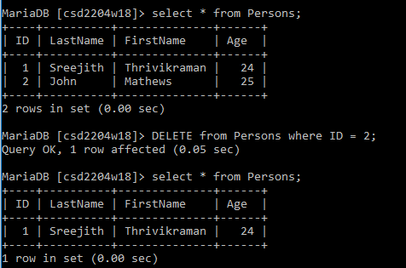

Difference:

**DELETE**

* For a delete statement, we can specify conditions in where clause.
* It is a DML command.
* It will delete the specific data if condition exists.
* Delete statement is slower than truncate statement.
* Rollback after DELETE statement is possible

**TRUNCATE**

* We can’t specify any conditions for TRUNCATE statement using where clause.
* It is a DDL command.
* It will delete the whole records in a table
* It has faster processing time.
* Rollback after TRUNCATE is not possible.